School of Informatics & IT

Diploma in Cybersecurity and Digital Forensics

CDF3C01 – Incident Response and Management (ICRM)

Lab 6 – Security Incident Response Management IV

Learning Outcomes
By the end of this practical lesson, the student should be able to demonstrate the following items:
- Extract artifacts from various network protocols observed within the provided PCAP file.
- Perform attack path mapping and attribution of the attacks to provide a bigger picture on the incident and its motives, through the usage of incident models learnt in the previous labs.

Tasks

Background / Scenario
Packet Capture (PCAP) analysis is the process of obtaining and analysing individual data packets that travel through the network. In the event of a security incident, PCAP files are normally extracted by security analysts to identify network anomalies and provide a timeline of events.
During the analysis phase, there might be instances where artefacts are extracted from the PCAP file to run through additional tests using other security scanners. You will be tasked to extract objects/artefacts from a variety of network services available for further analysis.

Exporting Objects from HTTP traffic

Setup of Analyst Workspace

Step 1: Launch Wireshark
- Boot up the ICRM-CENTOS8 Linux VM, and login with the following credentials:
- Username: root
- Password: enjoyit123
- Click on the ‘Activities’ column and launch the Wireshark application (left sidebar, 3rd icon from the top)
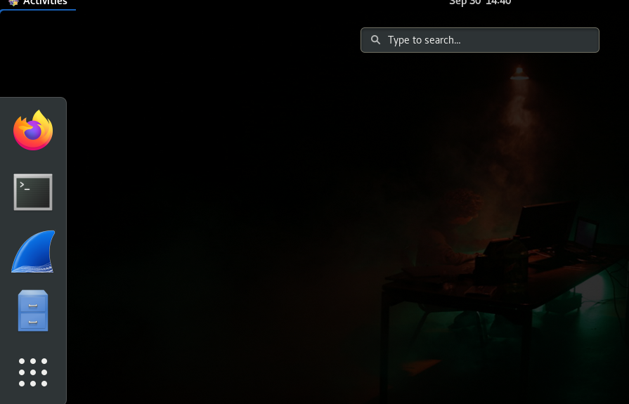
- When the application is launched, go to File > Open
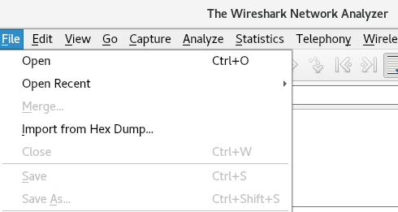
- Go to /root/wireshark_files folder and load up the extracting-objects-from-pcap-example-01.pcap file.
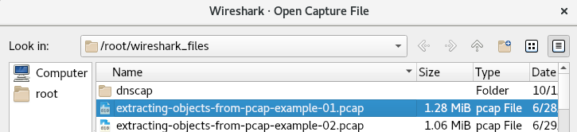

Step 2: Wireshark Column Display Setup
Configure the Wireshark GUI to display the following data in order (from left-most column to right-most column):
- Time (change it to UTC)
- Source
- Source Port (unresolved)
- Destination
- Destination Port (unresolved)
- Protocol
- Info

Analysis Phase

Step 1: Filter HTTP Requests
- Craft out the filter expression to display only HTTP requests
- Fill in the table below with regards to identification of hosts:
Victim IP
Attacker IP(s) + WHOIS Info
Note: If you want to install the WHOIS binary inside ICRM-MACHINE VM, type in the following command in Terminal (refer to screenshot below)
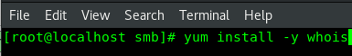
Why is it important to find out WHOIS information of the destination IP addresses?

Step 2: Analysing Exported Artefacts
- Go to File > Export Objects > HTTP, and click “Save All”. You can save them within the /root/wireshark_files folder.
- The artefacts that we are interested in are the Invoice&MSO-Request.doc and the knr.exe files. Using the file and sha256sum commands, fill up the table below:
File name
SHA-256 Hash
File Description

File name
SHA-256 Hash
File Description
- As it is an external artefact, you can check against online security tools such as VirusTotal (https://www.virustotal.com) to provide historical evidence of the referred artefact. The good thing about VirusTotal is that you do not need to provide the actual file itself, instead you can search based on IP addresses or even File Hashes.
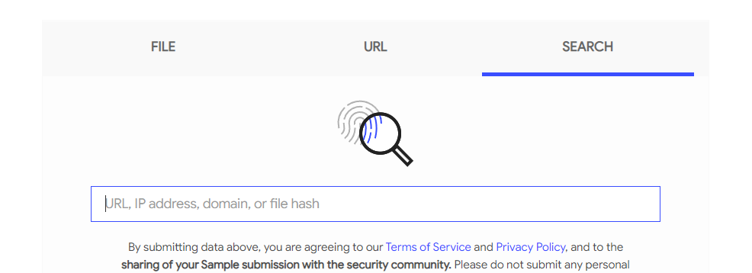
Go to the VirusTotal website, click the “Search” word, and paste the hash for each file. Take a close look at the information provided and browse through each of the tabs (especially the Behaviour) tab.

Step 3: Hypothesis Challenge
Based on the artefacts and the PCAP file alone, create a write-up of the attack using:
- Diamond Model
- Either one of the two threat mapping models that we learnt in Lab 1 & 2:
- Lockheed Martin’s Cyber Kill Chain
- MITRE ATT&CK Framework

Exporting Objects from SMB Traffic
Microsoft’s Server Message Block (SMB) protocol has been one of the most used service that are used by malware to spread across corporate Windows environments that are powered by the Active Directory (AD) service.

Setup of Analyst Workspace

Step 1: Launch Wireshark
- Boot up the ICRM-CENTOS8 Linux VM, and login with the following credentials:
- Username: root
- Password: enjoyit123
- Click on the ‘Activities’ column and launch the Wireshark application (left sidebar, 3rd icon from the top)
- When the application is launched, go to File > Open

- Go to /root/wireshark_files folder and load up the extracting-objects-from-pcap-example-03.pcap file.

Step 2: Wireshark Column Display Setup
Configure the Wireshark GUI to display the following data in order (from left-most column to right-most column):
- Time (change it to UTC)
- Source
- Source Port (unresolved)
- Destination
- Destination Port (unresolved)
- Protocol
- Info

Analysis Phase

Step 1: Filter SMB Requests
- Craft out the filter expression to display only SMB requests
- Fill in the table below with regards to identification of hosts:
Victim IP
Attacker IP(s) + WHOIS Info

Step 2: Analysing Exported Artefacts
- Go to File > Export Objects > SMB, and click “Save All”. You can save them within the /root/wireshark_files folder (there should be 4
- For each artefact, obtain the hash and the file description. Create a summary of the result displayed in VirusTotal.
File name 1
SHA-256 Hash
File Description
VirusTotal Summary

File name 2
SHA-256 Hash
File Description
VirusTotal Summary

File name 3
SHA-256 Hash
File Description
VirusTotal Summary

File name 4
SHA-256 Hash
File Description
VirusTotal Summary

Step 3: Hypothesis Challenge
Based on the artefacts and the PCAP file alone, create a write-up of the attack using:
- Diamond Model
- Either one of the two threat mapping models that we learnt in Lab 1 & 2:
- Lockheed Martin’s Cyber Kill Chain
- MITRE ATT&CK Framework

Exporting Emails from SMTP Traffic
Email communications serve as a useful source of evidence to investigate data leaks and initial access techniques that involve possible malware infections via emails. The main protocol in use for emails is the Simple Mail Transfer Protocol (SMTP), but for this example such SMTP data is sent unencrypted.

Setup of Analyst Workspace

Step 1: Launch Wireshark
- Boot up the ICRM-CENTOS8 Linux VM, and login with the following credentials:
- Username: root
- Password: enjoyit123
- Click on the ‘Activities’ column and launch the Wireshark application (left sidebar, 3rd icon from the top)

- When the application is launched, go to File > Open

- Go to /root/wireshark_files folder and load up the extracting-objects-from-pcap-example-04.pcap file.

Step 2: Wireshark Column Display Setup
Configure the Wireshark GUI to display the following data in order (from left-most column to right-most column):
- Time (change it to UTC)
- Source
- Source Port (unresolved)
- Destination
- Destination Port (unresolved)
- Protocol
- Info

Analysis Phase

Step 1: Filter SMTP Data Messages
- Use the following Wireshark display filter expression to only display SMTP data messages:
smtp.data.fragment
- Fill in the table below with regards to identification of hosts:
Victim IP
Attacker IP(s) + WHOIS Info

Step 2: Analysing Exported Artefacts
- Go to File > Export Objects > IMF, which stands for Internet Message Format.
- When clicking on Save All, do create a new folder called Emails to store all exported emails.
- Using the File Explorer, navigate to the Emails folder and look at all the emails.

Step 3: Hypothesis Challenge
Based on the artefacts and the PCAP file alone, create a write-up of the attack using:
- Diamond Model
- Either one of the two threat mapping models that we learnt in Lab 1 & 2:
- Lockheed Martin’s Cyber Kill Chain
- MITRE ATT&CK Framework

Exporting Files from FTP Traffic
Some malware families use FTP during malware infections. The next PCAP has malware executables retrieved from an FTP server followed by information from the infected Windows host sent back to the same FTP server.

Setup of Analyst Workspace

Step 1: Launch Wireshark
- Boot up the ICRM-CENTOS8 Linux VM, and login with the following credentials:
- Username: root
- Password: enjoyit123

- Click on the ‘Activities’ column and launch the Wireshark application (left sidebar, 3rd icon from the top)

- When the application is launched, go to File > Open

- Go to /root/wireshark_files folder and load up the extracting-objects-from-pcap-example-05.pcap file.

Step 2: Wireshark Column Display Setup
Configure the Wireshark GUI to display the following data in order (from left-most column to right-most column):
- Time (change it to UTC)
- Source
- Source Port (unresolved)
- Destination
- Destination Port (unresolved)
- Protocol
- Info

Analysis Phase

Step 1: Filter FTP Request Traffic
- Use the following Wireshark display filter expression to only display SMTP data messages:
ftp.request.command
- Based on the traffic, answer the following questions:
What is the username and password used to log into the FTP server?

How many Windows executable files are being transferred within the FTP server? List out the file names of the executables.

Are there any other files that are uploaded to the FTP server? What are they used for?

Step 2: Analysing Exported Artefacts
- Apply the following filter expression on Wireshark: ftp-data
- In this case, it is no longer possible to use the Export Objects function in Wireshark to export the objects. However, we can follow through the TCP streams to extract each data.
Right-click on any of the lines that end with (SIZE e.exe) to select one of the TCP segments, and select Follow > TCP Stream:
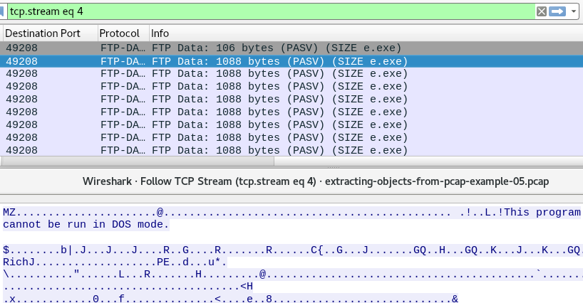
- Under “Show and save data as”, change from ASCII to Raw
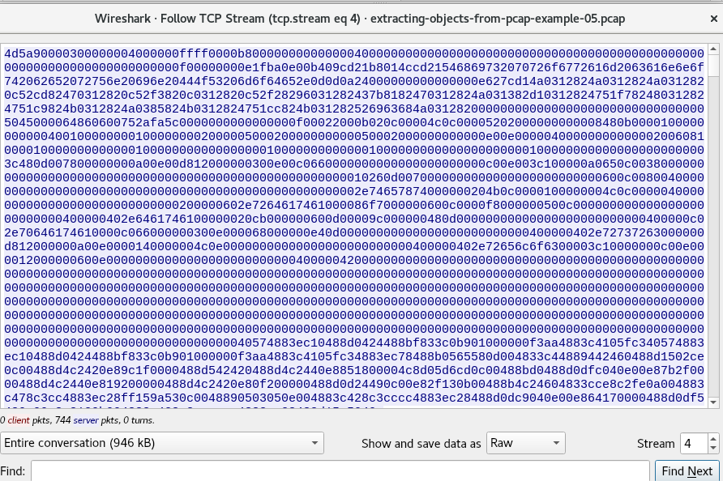
- Click on “Save As” and save it as “e.exe”
- In addition to the “e.exe”, extract the other executable files and the logs, and fill up the tables below for files transferred within the FTP traffic:

File name 1
SHA-256 Hash
File Description
VirusTotal Summary

File name 2
SHA-256 Hash
File Description
VirusTotal Summary

File name 3
SHA-256 Hash
File Description
VirusTotal Summary

File name 4
SHA-256 Hash
File Description
VirusTotal Summary

File name 5
SHA-256 Hash
File Description
VirusTotal Summary

File name 6
SHA-256 Hash
File Description
VirusTotal Summary

Step 3: Hypothesis Challenge
Based on the artefacts and the PCAP file alone, create a write-up of the attack using:
- Diamond Model
- Either one of the two threat mapping models that we learnt in Lab 1 & 2:
- Lockheed Martin’s Cyber Kill Chain
- MITRE ATT&CK Framework

